Modes of Operation for Relay Board

**Regular Temp (no switching power supply)**

-Only use AC Relay and Latching Relay

-Jumper J21. This allows the fan to turn on without the 3PDT relay

-R1 and R3 are not needed. Only use R2 if you intend to use a voltage, which is not the rated voltage of the supply. If R2 is used, Pin 9 and pin 3 of the 3PDT relay need to be connected with a 24 gauge wire.

-If no resistors are used Cosel Supply inputs (J9) will not be needed.

-Neslab AC (J16) can be used to power the AC fan. Jumper J18.

-Jumper J19. This allows the Athena to turn on without a usb signal.

-Do not use AC 5/12V Supply (J11) output on the relay board. The 5/12V supply must be powered up directly from the AC switch. If you prefer to use the AC 5/12V Supply output on relay board you can cut the AC live trace going to the AC 5/12V Supply (J11 pin1). Connect AC switch (J12 pin 2) to AC 5/12V Supply (J11 pin 1) using a 16 gauge wire. See Figure 2.

-Solder a 22uF cap and a 15k resistor across pin 1 and 7 of the latching relay. Pin 1 is ground for the capacitor. See Figure 1 and 2.

**High Temp (switching Power Supply)**

-Only use AC Relay, Latching Relay, 3PDT Relay and High Temp TTL relay

-R1 and R3 are not needed. R2 is used to set the low temp voltage. The high temp voltage will be the rated value of the supply.

-Neslab AC (J16) can be used to power the AC fan. Jumper J18.

-Jumper J19. This allows the Athena to turn on without a usb signal.

-Do not use AC 5/12V Supply (J11) output on the relay board. The 5/12V supply must be powered up directly from the AC switch. If you prefer to use the AC 5/12V Supply output on relay board you can cut the AC live trace going to the AC 5/12V Supply (J11 pin1). Connect AC switch (J12 pin 2) to AC 5/12V Supply (J11 pin 1) using a 16 gauge wire. See Figure 2.

-Solder a 22uF cap and a 15k resistor across pin 1 and 7 of the latching relay. Pin 1 is ground for the capacitor. See Figure 1 and 2.

**Low Temp (switching Power Supply)**

-Only use AC Relay, Latching Relay, 3PDT Relay, High Temp TTL relay and the Neslab TTL relay. Neslab TTL relay powers an external relay that passes the Neslab Current.

-R1 and R3 are not needed. R2 is used to set the low temp voltage. The high temp voltage will be the rated value of the supply.

-Jumper J19. This allows the Athena to turn on without a usb signal.

-Jumper the Level switch (J6).

-AC Pump (J2) or Heater AC (J3) can be used to power the AC fan.

-Do not use AC 5/12V Supply (J11) output on the relay board. The 5/12V supply must be powered up directly from the AC switch. If you prefer to use the AC 5/12V Supply output on relay board you can cut the AC live trace going to the AC 5/12V Supply (J11 pin1). Connect AC switch (J12 pin 2) to AC 5/12V Supply (J11 pin 1) using a 16 gauge wire. See Figure 2.

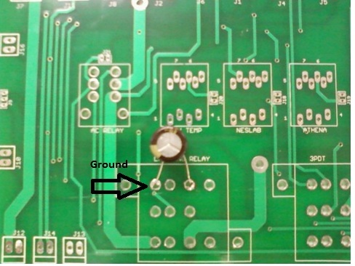

Figure 1- Capacitor

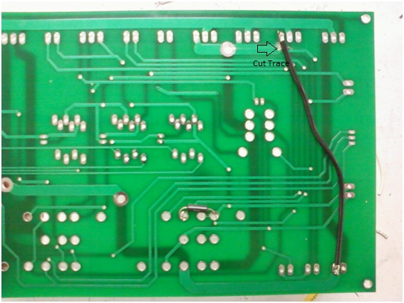

Figure 2 - Resistor + Jumper

i